# 0STYLE HUB– AN HOSPITAL MANAGEMENT WEBSITE FOR SHOPPING PROFESSIONAL TRAINING REPORT

**At**

SATHYABAMA INSTITUTE OF SCIENCE AND TECHNOLOGY

(DEEMED TO BE UNIVERSITY)

Submitted in partial fulfilment of the requirements for the award of Bachelor of Technology Degree in Information Technology

By

## DHARSINI M (41120054)

**DEPARTMENT OF INFORMATION TECHNOLOGY**

**SCHOOL OF COMPUTING**

**SATHYABAMA INSTITUTE OF SCIENCE AND TECHNOLOGY**

**JEPPIAAR NAGAR, RAJIV GANDHI SALAI,**

**CHENNAI – 600119, TAMILNADU**

|  |  |  |
| --- | --- | --- |
|  | **SATHYABAMA**  **INSTITUTE OF SCIENCE AND TECHNOLOGY** (DEEMED TO BE UNIVERSITY)  **Accredited with Grade “A++” by NAAC**  JEPPIAAR NAGAR, RAJIV GANDHI SALAI  CHENNAI– 600119 |  |

DEPARTMENT OF INFORMATION TECHNOLOGY

BONAFIDE CERTIFICATE

This is to certify that this Project Report is the bonafide work of **DHARSINI M (Reg.No:41120054)** who carried out the project entitled “**HOSPITAL MANAGEMENT SYSTEMWEBSITE USING FULL STACK DEVELOPMENT**” under my supervision from June 2023 to Sep 2023.

Internal Guide

Mrs.T.G.Ruby Angel, M.Tech

Head of the Department

Dr.R.SUBHASHINI, M.E., Ph.D.

Submitted for Viva voce Examination held on

Internal Examiner External Examiner

**

**INSTITUTE OF SCIENCE AND TECHNOLOGY**

**(DEEMED TO BE UNIVERSITY)**

**Accredited with Grade “A++” by NAAC**

JEPPIAAR NAGAR, RAJIV GANDHI SALAI

CHENNAI– 600119

**DECLARATION**

I,**DHARSINI M (41120054)** hereby declare that the PT-1 Report entitled **FULL STACK DEVELOPMENTWEBSITE USING REACTJS** done by me under the guidance of **Mrs.T.G. Ruby Angel, M.Tech** is submitted in partial fulfilment of the requirements for the award of Bachelor of Technology Degree in Information Technology.

## 

**DATE:**

**PLACE: CHENNAI SIGNATURE OF CANDIDATE**

**ACKNOWLEDGEMENT**

I am pleased to acknowledge my sincere thanks to **Board of Management** of **SATHYABAMA** for their kind encouragement in doing this project and for completing it successfully. I am grateful to them.

I convey my thanks to **Dr. T. Sasikala M.E., Ph.D.**, **Dean**, School of Computing,**Dr. R. Subhashini, M.E., Ph.D., Head of the Department** of **Information Technology** for providing me necessary support and details at the right time during the progressive reviews.

I wish to express my thanks to all Teaching and Non-teaching staff members of the **Department of Information Technology** who were helpful in many ways for the completion of the project.

TABLE OF CONTENTS

|  |  |  |  |  |
| --- | --- | --- | --- | --- |
| CHAPTERNO. | TITLE | | | PageNo. |
|  | ABSTRACT | | | v |
| 1 | INTRODUCTION | | | 2 |
|  | 1.1 | **PROBLEM STATEMENT** | | 4 |
|  | 1.2 | PROJECT STRUCTURE | | 5 |
| 2 | AIM AND SCOPE OF PROJECT | | |  |
|  | 2.1 | | AIM | 6 |
|  | 2.2 | | PROJECT OBJECTIVES | 6 |
|  | 2.3 | | SYSTEM SPECIFICATION | 8 |
|  | 2.4 | | SYSTEM ARCHITECTURE | 8 |
| 3 | EXPERIMENTAL ANALYSIS | | |  |
|  | 3.1 | EXISTING SYSTEM | | 9 |
|  | 3.2 | PROPOSED SYSTEM | | 10 |
| 4 | PROGRAM | | |  |
|  | 4.1 | FOLDER | | 16 |
|  | 4.2 | FRONTEND MODULE | | 16 |
|  | 4.3 | BACKEND MODULE | |  |
| 5 | RESULTS AND DISCUSSION | | |  |
|  | 5.1 | OUTPUT | | 29 |
| 6 | CONCLUSION AND REFERENCES | | |  |
|  | 6.1 | CONCLUSION | | 30 |
|  | 6.2 | REFERENCES | | 31 |

ABSTRACT

Hospital management system, also known as e-Business, or electronic business, is simply the sale and purchase of services and goods over an electronic medium, like the Internet.It also involves electronically transferring data and funds between two or more parties. Simply put, it is online shopping as we commonly know it.Hospital management system started way back in the 1960s when organizations began to use Electronic Data Interchange (EDI) to transfer documents of their business back and forth. The 1990s saw the emergence of online shopping businesses, which is quite a phenomenon today. The first-ever online purchase was a Sting CD, sold by US retailer, NetMarket on 11 August 1994.Hospital Management is nothing but a type of commerce.

Its functioning style is quite similar to that of the physical retail industry. The only difference it has with a brick-and-mortar store is that here, the entire process takes place online.

The journey of an Hospital Management firm begins with setting up an Hospital Management website. It is usually done with plugins like WooCommerce. After that, the products are displayed along with necessary details like product descriptions and price tags.

A CTA button like “Buy Now” is placed near the products for the convenience of the customers. If they feel like buying a product they can simply click on the button and make the payment.There are different payment methods used in the Hospital Management industry. Buyers either can make the payment through a payment gateway like PayPal or they can use their credit cards.

There is another option called COD or cash on delivery. This is mainly preferred by senior customers

**CHAPTER – 1**

**INTRODUCTION**

Hospital management system is a website that allows people to buy and sell physical goods, services, and digital products over the internet rather than at a brick-and-mortar location. Through an hospital management system website, a business can process orders, accept payments, manage shipping and logistics, and provide customer service.An hospital management system website is one that allows people to buy and sell physical goods, services, and digital products over the internet rather than at a brick-and-mortar location. Through an hospital management system website, a business can process orders, accept payments, manage shipping and logistics, and provide customer service.

It’s tough to imagine daily life without hospital management system. We order food, clothes, and furniture; we register for classes and other online services; we download books, music, and movies; and so much more. Hospital management system has taken root and is here to stay.

The term “[hospital management system](https://mailchimp.com/marketing-glossary/e-commerce/)” simply means the sale of goods or services on the internet. In its most basic form, hospital management system involves electronically transferring funds and data between 2 or more parties. This form of business has evolved quite a bit since its beginnings in the [electronic data interchange](https://www.edibasics.com/what-is-edi/) of the 1960s and the inception of online shopping in the 1990s.

Inevitably, your customers will need to communicate with you about their order or experience. They may need to correct their personal information, make an exchange, or return a faulty product. Your website is where these customers will turn to get in touch with you. The easier you make it for customers to connect—with a contact form or chat service,Just like in a physical store, an [abandoned cart](https://mailchimp.com/marketing-glossary/abandoned-cart/) in hospital management system is one that has been filled and deserted by the shopper. While abandoned carts can be frustrating as a seller, they’re not always a bad sign. Many shoppers use their carts as a wishlist or placeholder as they look around for the right product.

The only difference is that on an hospital management system website, you don’t have to deal with a human to be able to buy and get your items delivered to your doorstep. An Hospital Management website must be as functional as it is with or without the owners or managers monitoring the site and dealing with their customers every second of the day.

We are going to make a simple Hospital Management app.Regardless, you want customers to re-engage and buy those items in their cart. You can encourage them to complete their purchase by offering a discount or nudging them with a promotional email.

.

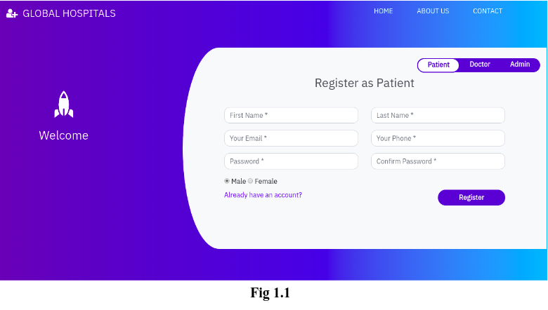

**Fig1 Hospital management system Website**

* 1. **PROBLEM STATEMENT:**

The aim of this study is to design and implement a database driven online virtual marketplace with a particular reference to main market. Hospital management system provides an easy way to connect to a large customer base. However, there is a lot of competition among multiple hospital management system sites. When users land on an hospital management system site, they expect to find what they are looking for quickly and easily. Also, users are not sure about the brands or the actual products they want to purchase. They have a very broad idea about what they want to buy.To implement a design a better pricing mechanism in the market .

To solve the problem of geographical locationand to maximize the sales.

**1.2 PROJECT STRUCTURE:**The project structure will look like

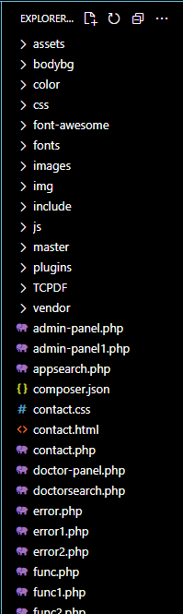

**Fig 1.3.1 Project Structure**

**CHAPTER – 2**

**AIM AND SCOPE OF PROJECT**

**2.1AIM:**

To create Hospital management system website using Fullstack

**2.2 PROJECT OBJECTIVES:**

* Hospital Management businesses are the need of the moment and almost all large and small companies are taking the online route to enhance their sales and to effectively compete with similar businesses online. To turn your online business into a successful one, it is mandatory to have an in-depth understanding of how Hospital Management business works, its features and characteristics and the objective of Hospital Management.
* There are various features of an Hospital Management business and you should be aware of all of them to set up business online. Let us understand what these features are all about.

### Technology-Enabled Hospital Management can be implemented through this website.

* Traditional commerce has been taking place since times immemorial but Hospital Management is the result of the integration of digital technology with commercial transactions and business processes. The technological foundations of Hospital management system are the internet, World Wide Web (WWW) and various other protocols.
* The number of customers for a traditional business is restricted in the city where it is located, whereas an Hospital Management business can reach globally. Hospital Management can be defined as a virtual marketplace that can be accessed online by customers through devices like mobile phones and computers.
* Thus, an Hospital Management marketplace motivates customers to buy products & services from any corner of the world where internet connection is available and then can pay the payment online. Due to the ubiquitous nature of the Hospital Management business, the working hours and geographical boundaries of catering enhance.
* Objective of Hospital Management for Hospital Management businesses have reached customers located all around the world. The Internet connects national boundaries. Hospital Management, without being limited by national and cultural boundaries, provides an opportunity to businessmen to cater to the customers seamlessly. This kind of marketplace has the capability to reach millions of worldwide customers.
* In Hospital Management businesses, buyers and sellers meet in cyber space rather than physical place. Hence, Hospital Management does not involve face to face contact.
* Commercial trading of products takes place through websites in Hospital Management. An Hospital Management website must be created based on the universally accepted methods and systems. Maintaining global standards aids the users of an Hospital Management website to efficiently use the website. Thus, universality of the website is one of the most essential features of an Hospital Management business.
* Interactivity serves as another important feature of an Hospital Management business. It refers to the two-way communication between the businesses and users of the Hospital Management website.
* **2.3 SYSTEM SPECIFICATION:**

**HARDWARE SPECIFICATION**

Processor : Processor Intel CORE i3 and above

RAM : 4 GB

Mouse : Digital

Keyboard : 105 Digital Keys

**SOFTWARE SPECIFICATION**

Operating System : Windows

Language : HTML, CSS, JAVASCRIPT, FULL STACK DEVELOPMENT.

GUI : Visual Studio (VS CODE).

**2.4 SYSTEM ARCHITECTURE:**

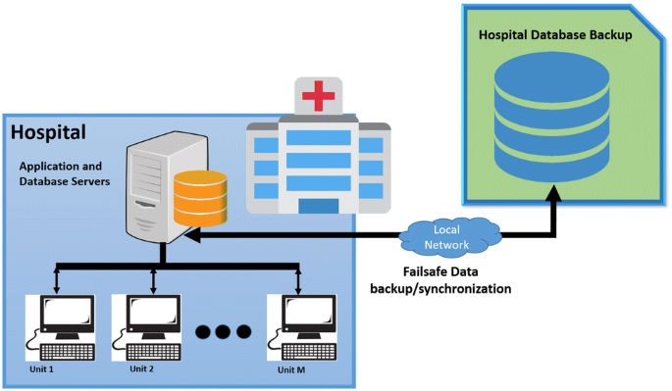

**Fig2.4.1 System Architecture**

**CHAPTER – 3**

**EXPERIMENTAL ANALYSIS**

## 3.1 EXISTING SYSTEM

**​**Conducting an experimental analysis of hospital management websites involves assessing various aspects of their design, functionality, and user experience. Here is a step-by-step guide to help you conduct such an analysis:

**1. Define Objectives:**

- Clarify the purpose of the analysis: Identify the key aspects you want to evaluate, such as usability, accessibility, information accuracy, and overall user satisfaction.

**2. Select Evaluation Criteria:**

- Choose specific criteria for evaluation based on your objectives. This may include:

- Usability: Navigation, layout, clarity of information.

- Accessibility: Compliance with accessibility standards (WCAG), catering to users with disabilities.

- Performance: Page load times, responsiveness.

- Content: Accuracy, relevancy, completeness of medical information.

- Security: Data protection and privacy measures.

- User Interaction: Forms, appointment booking, feedback mechanisms.

- Design: Aesthetics, consistency, readability.

**3. Create Test Scenarios:**

- Develop realistic scenarios that users might encounter, such as finding a doctor, scheduling an appointment, or accessing medical records.

**4.Select Participants:**

- Recruit a diverse group of participants representing your target audience. Include individuals with varying levels of technical expertise.

**5. Execute the Evaluation:**

- Have participants perform tasks based on the test scenarios while observing and collecting data on their interactions.

- Use tools like screen recording, eye-tracking, or usability testing platforms to gather qualitative and quantitative data.

**6. Evaluate Accessibility:**

- Check for adherence to accessibility standards (e.g., WCAG) to ensure that the website is usable by individuals with disabilities.

**7. Performance Testing:**

- Assess the website's performance in terms of page load times and responsiveness, particularly on different devices and network speeds.

**8. Evaluate Security Measures:**

- Examine the website's security protocols, especially regarding patient data protection and privacy.

**9. Analyze User Feedback:**

- Collect feedback through surveys, interviews, or user comments to understand user perceptions and preferences.

**10. Report and Interpret Findings:**

- Summarize your findings, providing insights into strengths, weaknesses, and areas for improvement.

- Include actionable recommendations for enhancing the website's overall functionality and user experience.

**11. Iterative Testing and Improvement:**

- Conduct follow-up tests after implementing recommended changes to assess the impact and identify any new issues.

**12. Documentation:**

-Document your methodology, findings, and recommendations for future reference.

Remember, this analysis should be an ongoing process to keep the hospital management website aligned with user needs and technological advancements.

## PROPOSED SYSTEM

## Objectives:

## Clearly state the objectives of the proposed system. For example:

## Enhance overall hospital management efficiency.

## Improve patient care and experience.

## Streamline administrative processes.

## Ensure secure and compliant data handling..

**Key Features** **:**

Outline the essential features of the proposed hospital management system

* Patient Registration and Management: Streamlined processes for patient information entry, retrieval, and management.
* Appointment Scheduling: Efficient online scheduling for patients and doctors.
* Electronic Health Records (EHR): Secure storage and easy retrieval of patient health records.
* Billing and Invoicing: Automated billing processes for accurate financial transactions.
* Inventory Management: Monitoring and managing medical supplies and equipment.
* Doctor and Staff Management: Tracking schedules, performance, and workload.

Reporting and Analytics: Generate insights for informed decision-making.

**User Interface and Experience:**

Emphasize the importance of an intuitive and user-friendly interface to enhance the user experience.

Discuss the design principles that contribute to a positive user interaction.

**Integration and Compatibility:**

Explain how the proposed system will integrate with existing hospital infrastructure and software.

Highlight compatibility with various devices and browsers for accessibility.

**Security Measures:**

Discuss the security protocols implemented to safeguard patient data and comply with privacy regulations.

Include encryption, access controls, and regular security audits.

**Scalability:**

Address the system's scalability to accommodate the hospital's growth and evolving needs.

Describe how the system can handle an increasing volume of patients, staff, and data

**CHAPTER 4**

**PROGRAM**

**4.1 FOLDER**

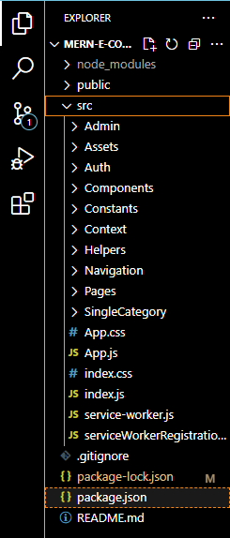 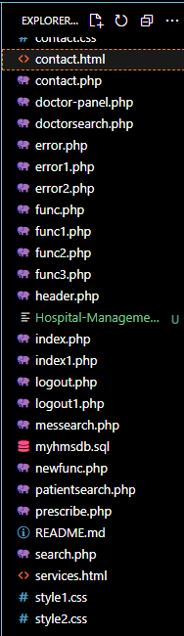

**Fig 4.1.1 Visual Code Side Bar**

4.2 FRONTEND MODULE

***.****<html>*

*<head>*

*<title>HMS</title>*

*<link rel="shortcut icon" type="image/x-icon" href="images/favicon.png" />*

*<link rel="stylesheet" type="text/css" href="style1.css">*

*<link href="https://fonts.googleapis.com/css?family=IBM+Plex+Sans&display=swap" rel="stylesheet">*

*<!-- <link rel="stylesheet" href="https://stackpath.bootstrapcdn.com/bootstrap/3.4.1/css/bootstrap.min.css" integrity="sha384-HSMxcRTRxnN+Bdg0JdbxYKrThecOKuH5zCYotlSAcp1+c8xmyTe9GYg1l9a69psu" crossorigin="anonymous"> -->*

*<link rel="stylesheet" href="https://stackpath.bootstrapcdn.com/bootstrap/4.3.1/css/bootstrap.min.css" integrity="sha384-ggOyR0iXCbMQv3Xipma34MD+dH/1fQ784/j6cY/iJTQUOhcWr7x9JvoRxT2MZw1T" crossorigin="anonymous">*

*<link rel="stylesheet" href="vendor/fontawesome/css/font-awesome.min.css">*

*<link href="//maxcdn.bootstrapcdn.com/bootstrap/4.1.1/css/bootstrap.min.css" rel="stylesheet" id="bootstrap-css">*

*<style >*

*.form-control {*

*border-radius: 0.75rem;*

*}*

*</style>*

*<script>*

*var check = function() {*

*if (document.getElementById('password').value ==*

*document.getElementById('cpassword').value) {*

*document.getElementById('message').style.color = '#5dd05d';*

*document.getElementById('message').innerHTML = 'Matched';*

*} else {*

*document.getElementById('message').style.color = '#f55252';*

*document.getElementById('message').innerHTML = 'Not Matching';*

*}*

*}*

*function alphaOnly(event) {*

*var key = event.keyCode;*

*return ((key >= 65 && key <= 90) || key == 8 || key == 32);*

*};*

*function checklen()*

*{*

*var pass1 = document.getElementById("password");*

*if(pass1.value.length<6){*

*alert("Password must be at least 6 characters long. Try again!");*

*return false;*

*}*

*}*

*</script>*

*</head>*

*<!------ Include the above in your HEAD tag ---------->*

*<body>*

*<nav class="navbar navbar-expand-lg navbar-dark fixed-top" id="mainNav" >*

*<div class="container">*

*<a class="navbar-brand js-scroll-trigger" href="#" style="margin-top: 10px;margin-left:-65px;font-family: 'IBM Plex Sans', sans-serif;"><h4><i class="fa fa-user-plus" aria-hidden="true"></i>&nbsp GLOBAL HOSPITALS</h4></a>*

*<button class="navbar-toggler" type="button" data-toggle="collapse" data-target="#navbarResponsive" aria-controls="navbarResponsive" aria-expanded="false" aria-label="Toggle navigation">*

*<span class="navbar-toggler-icon"></span>*

*</button>*

*<div class="collapse navbar-collapse" id="navbarResponsive">*

*<ul class="navbar-nav ml-auto">*

*<li class="nav-item" style="margin-right: 40px;">*

*<a class="nav-link js-scroll-trigger" href="index.php" style="color: white;font-family: 'IBM Plex Sans', sans-serif;"><h6>HOME</h6></a>*

*</li>*

*<li class="nav-item" style="margin-right: 40px;">*

*<a class="nav-link js-scroll-trigger" href="services.html" style="color: white;font-family: 'IBM Plex Sans', sans-serif;"><h6>ABOUT US</h6></a>*

*</li>*

*<li class="nav-item">*

*<a class="nav-link js-scroll-trigger" href="contact.html" style="color: white;font-family: 'IBM Plex Sans', sans-serif;"><h6>CONTACT</h6></a>*

*</li>*

*</ul>*

*</div>*

*</div>*

*</nav>*

*<div class="container register" style="font-family: 'IBM Plex Sans', sans-serif;">*

*<div class="row">*

*<div class="col-md-3 register-left" style="margin-top: 10%;right: 5%">*

*<img src="https://image.ibb.co/n7oTvU/logo_white.png" alt=""/>*

*<h3>Welcome</h3>*

*</div>*

*<div class="col-md-9 register-right" style="margin-top: 40px;left: 80px;">*

*<ul class="nav nav-tabs nav-justified" id="myTab" role="tablist" style="width: 40%;">*

*<li class="nav-item">*

*<a class="nav-link active" id="home-tab" data-toggle="tab" href="#home" role="tab" aria-controls="home" aria-selected="true">Patient</a>*

*</li>*

*<li class="nav-item">*

*<a class="nav-link" id="profile-tab" data-toggle="tab" href="#profile" role="tab" aria-controls="profile" aria-selected="false">Doctor</a>*

*</li>*

*<li class="nav-item">*

*<a class="nav-link" id="profile-tab" data-toggle="tab" href="#admin" role="tab" aria-controls="admin" aria-selected="false">Receptionist</a>*

*</li>*

*</ul>*

*<div class="tab-content" id="myTabContent">*

*<div class="tab-pane fade show active" id="home" role="tabpanel" aria-labelledby="home-tab">*

*<h3 class="register-heading">Register as Patient</h3>*

*<form method="post" action="func2.php">*

*<div class="row register-form">*

*<div class="col-md-6">*

*<div class="form-group">*

*<input type="text" class="form-control" placeholder="First Name *" name="fname" onkeydown="return alphaOnly(event);" required/>*

*</div>*

*<div class="form-group">*

*<input type="email" class="form-control" placeholder="Your Email *" name="email" />*

*</div>*

*<div class="form-group">*

*<input type="password" class="form-control" placeholder="Password *" id="password" name="password" onkeyup='check();' required/>*

*</div>*

*<div class="form-group">*

*<div class="maxl">*

*<label class="radio inline">*

*<input type="radio" name="gender" value="Male" checked>*

*<span> Male </span>*

*</label>*

*<label class="radio inline">*

*<input type="radio" name="gender" value="Female">*

*<span>Female </span>*

*</label>*

*</div>*

*<a href="index1.php">Already have an account?</a>*

*</div>*

*</div>*

*<div class="col-md-6">*

*<div class="form-group">*

*<input type="text" class="form-control" placeholder="Last Name *" name="lname" onkeydown="return alphaOnly(event);" required/>*

*</div>*

*<div class="form-group">*

*<input type="tel" minlength="10" maxlength="10" name="contact" class="form-control" placeholder="Your Phone *" />*

*</div>*

*<div class="form-group">*

*<input type="password" class="form-control" id="cpassword" placeholder="Confirm Password *" name="cpassword" onkeyup='check();' required/><span id='message'></span>*

*</div>*

*<input type="submit" class="btnRegister" name="patsub1" onclick="return checklen();" value="Register"/>*

*</div>*

*</div>*

*</form>*

*</div>*

*<div class="tab-pane fade show" id="profile" role="tabpanel" aria-labelledby="profile-tab">*

*<h3 class="register-heading">Login as Doctor</h3>*

*<form method="post" action="func1.php">*

*<div class="row register-form">*

*<div class="col-md-6">*

*<div class="form-group">*

*<input type="text" class="form-control" placeholder="User Name *" name="username3" onkeydown="return alphaOnly(event);" required/>*

*</div>*

*</div>*

*<div class="col-md-6">*

*<div class="form-group">*

*<input type="password" class="form-control" placeholder="Password *" name="password3" required/>*

*</div>*

*<input type="submit" class="btnRegister" name="docsub1" value="Login"/>*

*</div>*

*</div>*

*</form>*

*</div>*

*<div class="tab-pane fade show" id="admin" role="tabpanel" aria-labelledby="profile-tab">*

*<h3 class="register-heading">Login as Admin</h3>*

*<form method="post" action="func3.php">*

*<div class="row register-form">*

*<div class="col-md-6">*

*<div class="form-group">*

*<input type="text" class="form-control" placeholder="User Name *" name="username1" onkeydown="return alphaOnly(event);" required/>*

*</div>*

*</div>*

*<div class="col-md-6">*

*<div class="form-group">*

*<input type="password" class="form-control" placeholder="Password *" name="password2" required/>*

*</div>*

*<input type="submit" class="btnRegister" name="adsub" value="Login"/>*

*</div>*

*</div>*

*</form>*

*</div>*

*</div>*

*</div>*

*</div>*

*</div>*

*</body>*

*<script src="https://code.jquery.com/jquery-3.3.1.slim.min.js" integrity="sha384-q8i/X+965DzO0rT7abK41JStQIAqVgRVzpbzo5smXKp4YfRvH+8abtTE1Pi6jizo" crossorigin="anonymous"></script>*

*<script src="https://cdnjs.cloudflare.com/ajax/libs/popper.js/1.14.7/umd/popper.min.js" integrity="sha384-UO2eT0CpHqdSJQ6hJty5KVphtPhzWj9WO1clHTMGa3JDZwrnQq4sF86dIHNDz0W1" crossorigin="anonymous"></script>*

*<script src="https://stackpath.bootstrapcdn.com/bootstrap/4.3.1/js/bootstrap.min.js" integrity="sha384-JjSmVgyd0p3pXB1rRibZUAYoIIy6OrQ6VrjIEaFf/nJGzIxFDsf4x0xIM+B07jRM" crossorigin="anonymous"></script>*

*<script src="https://stackpath.bootstrapcdn.com/bootstrap/3.4.1/js/bootstrap.min.js" integrity="sha384-aJ21OjlMXNL5UyIl/XNwTMqvzeRMZH2w8c5cRVpzpU8Y5bApTppSuUkhZXN0VxHd" crossorigin="anonymous"></script>*

*</html>*

**4.3 BACKEND MODULE**

*-- phpMyAdmin SQL Dump*

*-- version 4.8.0*

*-- https://www.phpmyadmin.net/*

*--*

*-- Host: localhost*

*-- Generation Time: Mar 16, 2020 at 02:34 AM*

*-- Server version: 10.1.31-MariaDB*

*-- PHP Version: 7.2.4*

*SET SQL_MODE = "NO_AUTO_VALUE_ON_ZERO";*

*SET AUTOCOMMIT = 0;*

*START TRANSACTION;*

*SET time_zone = "+00:00";*

*/*!40101 SET @OLD_CHARACTER_SET_CLIENT=@@CHARACTER_SET_CLIENT */;*

*/*!40101 SET @OLD_CHARACTER_SET_RESULTS=@@CHARACTER_SET_RESULTS */;*

*/*!40101 SET @OLD_COLLATION_CONNECTION=@@COLLATION_CONNECTION */;*

*/*!40101 SET NAMES utf8mb4 */;*

*--*

*-- Database: `myhmsdb`*

*--*

*-- --------------------------------------------------------*

*--*

*-- Table structure for table `admintb`*

*--*

*CREATE TABLE `admintb` (*

*`username` varchar(50) NOT NULL,*

*`password` varchar(30) NOT NULL*

*) ENGINE=InnoDB DEFAULT CHARSET=latin1;*

*--*

*-- Dumping data for table `admintb`*

*--*

*INSERT INTO `admintb` (`username`, `password`) VALUES*

*('admin', 'admin123');*

*-- --------------------------------------------------------*

*--*

*-- Table structure for table `appointmenttb`*

*--*

*CREATE TABLE `appointmenttb` (*

*`pid` int(11) NOT NULL,*

*`ID` int(11) NOT NULL,*

*`fname` varchar(20) NOT NULL,*

*`lname` varchar(20) NOT NULL,*

*`gender` varchar(10) NOT NULL,*

*`email` varchar(30) NOT NULL,*

*`contact` varchar(10) NOT NULL,*

*`doctor` varchar(30) NOT NULL,*

*`docFees` int(5) NOT NULL,*

*`appdate` date NOT NULL,*

*`apptime` time NOT NULL,*

*`userStatus` int(5) NOT NULL,*

*`doctorStatus` int(5) NOT NULL*

*) ENGINE=InnoDB DEFAULT CHARSET=latin1;*

*--*

*-- Dumping data for table `appointmenttb`*

*--*

*INSERT INTO `appointmenttb` (`pid`, `ID`, `fname`, `lname`, `gender`, `email`, `contact`, `doctor`, `docFees`, `appdate`, `apptime`, `userStatus`, `doctorStatus`) VALUES*

*(4, 1, 'Kishan', 'Lal', 'Male', 'kishansmart0@gmail.com', '8838489464', 'Ganesh', 550, '2020-02-14', '10:00:00', 1, 0),*

*(4, 2, 'Kishan', 'Lal', 'Male', 'kishansmart0@gmail.com', '8838489464', 'Dinesh', 700, '2020-02-28', '10:00:00', 0, 1),*

*(4, 3, 'Kishan', 'Lal', 'Male', 'kishansmart0@gmail.com', '8838489464', 'Amit', 1000, '2020-02-19', '03:00:00', 0, 1),*

*(11, 4, 'Shraddha', 'Kapoor', 'Female', 'shraddha@gmail.com', '9768946252', 'ashok', 500, '2020-02-29', '20:00:00', 1, 1),*

*(4, 5, 'Kishan', 'Lal', 'Male', 'kishansmart0@gmail.com', '8838489464', 'Dinesh', 700, '2020-02-28', '12:00:00', 1, 1),*

*(4, 6, 'Kishan', 'Lal', 'Male', 'kishansmart0@gmail.com', '8838489464', 'Ganesh', 550, '2020-02-26', '15:00:00', 0, 1),*

*(2, 8, 'Alia', 'Bhatt', 'Female', 'alia@gmail.com', '8976897689', 'Ganesh', 550, '2020-03-21', '10:00:00', 1, 1),*

*(5, 9, 'Gautam', 'Shankararam', 'Male', 'gautam@gmail.com', '9070897653', 'Ganesh', 550, '2020-03-19', '20:00:00', 1, 0),*

*(4, 10, 'Kishan', 'Lal', 'Male', 'kishansmart0@gmail.com', '8838489464', 'Ganesh', 550, '0000-00-00', '14:00:00', 1, 0),*

*(4, 11, 'Kishan', 'Lal', 'Male', 'kishansmart0@gmail.com', '8838489464', 'Dinesh', 700, '2020-03-27', '15:00:00', 1, 1),*

*(9, 12, 'William', 'Blake', 'Male', 'william@gmail.com', '8683619153', 'Kumar', 800, '2020-03-26', '12:00:00', 1, 1),*

*(9, 13, 'William', 'Blake', 'Male', 'william@gmail.com', '8683619153', 'Tiwary', 450, '2020-03-26', '14:00:00', 1, 1);*

*-- --------------------------------------------------------*

*--*

*-- Table structure for table `contact`*

*--*

*CREATE TABLE `contact` (*

*`name` varchar(30) NOT NULL,*

*`email` text NOT NULL,*

*`contact` varchar(10) NOT NULL,*

*`message` varchar(200) NOT NULL*

*) ENGINE=InnoDB DEFAULT CHARSET=latin1;*

*--*

*-- Dumping data for table `contact`*

*--*

*INSERT INTO `contact` (`name`, `email`, `contact`, `message`) VALUES*

*('Anu', 'anu@gmail.com', '7896677554', 'Hey Admin'),*

*(' Viki', 'viki@gmail.com', '9899778865', 'Good Job, Pal'),*

*('Ananya', 'ananya@gmail.com', '9997888879', 'How can I reach you?'),*

*('Aakash', 'aakash@gmail.com', '8788979967', 'Love your site'),*

*('Mani', 'mani@gmail.com', '8977768978', 'Want some coffee?'),*

*('Karthick', 'karthi@gmail.com', '9898989898', 'Good service'),*

*('Abbis', 'abbis@gmail.com', '8979776868', 'Love your service'),*

*('Asiq', 'asiq@gmail.com', '9087897564', 'Love your service. Thank you!'),*

*('Jane', 'jane@gmail.com', '7869869757', 'I love your service!');*

*-- --------------------------------------------------------*

*--*

*-- Table structure for table `doctb`*

*--*

*CREATE TABLE `doctb` (*

*`username` varchar(50) NOT NULL,*

*`password` varchar(50) NOT NULL,*

*`email` varchar(50) NOT NULL,*

*`spec` varchar(50) NOT NULL,*

*`docFees` int(10) NOT NULL*

*) ENGINE=InnoDB DEFAULT CHARSET=latin1;*

*--*

*-- Dumping data for table `doctb`*

*--*

*INSERT INTO `doctb` (`username`, `password`, `email`, `spec`, `docFees`) VALUES*

*('ashok', 'ashok123', 'ashok@gmail.com', 'General', 500),*

*('arun', 'arun123', 'arun@gmail.com', 'Cardiologist', 600),*

*('Dinesh', 'dinesh123', 'dinesh@gmail.com', 'General', 700),*

*('Ganesh', 'ganesh123', 'ganesh@gmail.com', 'Pediatrician', 550),*

*('Kumar', 'kumar123', 'kumar@gmail.com', 'Pediatrician', 800),*

*('Amit', 'amit123', 'amit@gmail.com', 'Cardiologist', 1000),*

*('Abbis', 'abbis123', 'abbis@gmail.com', 'Neurologist', 1500),*

*('Tiwary', 'tiwary123', 'tiwary@gmail.com', 'Pediatrician', 450);*

*-- --------------------------------------------------------*

*--*

*-- Table structure for table `patreg`*

*--*

*CREATE TABLE `patreg` (*

*`pid` int(11) NOT NULL,*

*`fname` varchar(20) NOT NULL,*

*`lname` varchar(20) NOT NULL,*

*`gender` varchar(10) NOT NULL,*

*`email` varchar(30) NOT NULL,*

*`contact` varchar(10) NOT NULL,*

*`password` varchar(30) NOT NULL,*

*`cpassword` varchar(30) NOT NULL*

*) ENGINE=InnoDB DEFAULT CHARSET=latin1;*

*--*

*-- Dumping data for table `patreg`*

*--*

*INSERT INTO `patreg` (`pid`, `fname`, `lname`, `gender`, `email`, `contact`, `password`, `cpassword`) VALUES*

*(1, 'Ram', 'Kumar', 'Male', 'ram@gmail.com', '9876543210', 'ram123', 'ram123'),*

*(2, 'Alia', 'Bhatt', 'Female', 'alia@gmail.com', '8976897689', 'alia123', 'alia123'),*

*(3, 'Shahrukh', 'khan', 'Male', 'shahrukh@gmail.com', '8976898463', 'shahrukh123', 'shahrukh123'),*

*(4, 'Kishan', 'Lal', 'Male', 'kishansmart0@gmail.com', '8838489464', 'kishan123', 'kishan123'),*

*(5, 'Gautam', 'Shankararam', 'Male', 'gautam@gmail.com', '9070897653', 'gautam123', 'gautam123'),*

*(6, 'Sushant', 'Singh', 'Male', 'sushant@gmail.com', '9059986865', 'sushant123', 'sushant123'),*

*(7, 'Nancy', 'Deborah', 'Female', 'nancy@gmail.com', '9128972454', 'nancy123', 'nancy123'),*

*(8, 'Kenny', 'Sebastian', 'Male', 'kenny@gmail.com', '9809879868', 'kenny123', 'kenny123'),*

*(9, 'William', 'Blake', 'Male', 'william@gmail.com', '8683619153', 'william123', 'william123'),*

*(10, 'Peter', 'Norvig', 'Male', 'peter@gmail.com', '9609362815', 'peter123', 'peter123'),*

*(11, 'Shraddha', 'Kapoor', 'Female', 'shraddha@gmail.com', '9768946252', 'shraddha123', 'shraddha123');*

*-- --------------------------------------------------------*

*--*

*-- Table structure for table `prestb`*

*--*

*CREATE TABLE `prestb` (*

*`doctor` varchar(50) NOT NULL,*

*`pid` int(11) NOT NULL,*

*`ID` int(11) NOT NULL,*

*`fname` varchar(50) NOT NULL,*

*`lname` varchar(50) NOT NULL,*

*`appdate` date NOT NULL,*

*`apptime` time NOT NULL,*

*`disease` varchar(250) NOT NULL,*

*`allergy` varchar(250) NOT NULL,*

*`prescription` varchar(1000) NOT NULL*

*) ENGINE=InnoDB DEFAULT CHARSET=latin1;*

*--*

*-- Dumping data for table `prestb`*

*--*

*INSERT INTO `prestb` (`doctor`, `pid`, `ID`, `fname`, `lname`, `appdate`, `apptime`, `disease`, `allergy`, `prescription`) VALUES*

*('Dinesh', 4, 11, 'Kishan', 'Lal', '2020-03-27', '15:00:00', 'Cough', 'Nothing', 'Just take a teaspoon of Benadryl every night'),*

*('Ganesh', 2, 8, 'Alia', 'Bhatt', '2020-03-21', '10:00:00', 'Severe Fever', 'Nothing', 'Take bed rest'),*

*('Kumar', 9, 12, 'William', 'Blake', '2020-03-26', '12:00:00', 'Sever fever', 'nothing', 'Paracetamol -> 1 every morning and night'),*

*('Tiwary', 9, 13, 'William', 'Blake', '2020-03-26', '14:00:00', 'Cough', 'Skin dryness', 'Intake fruits with more water content');*

*--*

*-- Indexes for dumped tables*

*--*

*--*

*-- Indexes for table `appointmenttb`*

*--*

*ALTER TABLE `appointmenttb`*

*ADD PRIMARY KEY (`ID`);*

*--*

*-- Indexes for table `patreg`*

*--*

*ALTER TABLE `patreg`*

*ADD PRIMARY KEY (`pid`);*

*--*

*-- AUTO_INCREMENT for dumped tables*

*--*

*--*

*-- AUTO_INCREMENT for table `appointmenttb`*

*--*

*ALTER TABLE `appointmenttb`*

*MODIFY `ID` int(11) NOT NULL AUTO_INCREMENT, AUTO_INCREMENT=14;*

*--*

*-- AUTO_INCREMENT for table `patreg`*

*--*

*ALTER TABLE `patreg`*

*MODIFY `pid` int(11) NOT NULL AUTO_INCREMENT, AUTO_INCREMENT=12;*

*COMMIT;*

*/*!40101 SET CHARACTER_SET_CLIENT=@OLD_CHARACTER_SET_CLIENT */;*

*/*!40101 SET CHARACTER_SET_RESULTS=@OLD_CHARACTER_SET_RESULTS */;*

*/*!40101 SET COLLATION_CONNECTION=@OLD_COLLATION_CONNECTION */;*

**CHAPTER 5**

**OUTPUT**

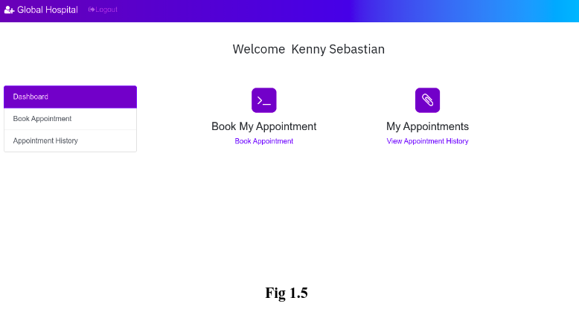

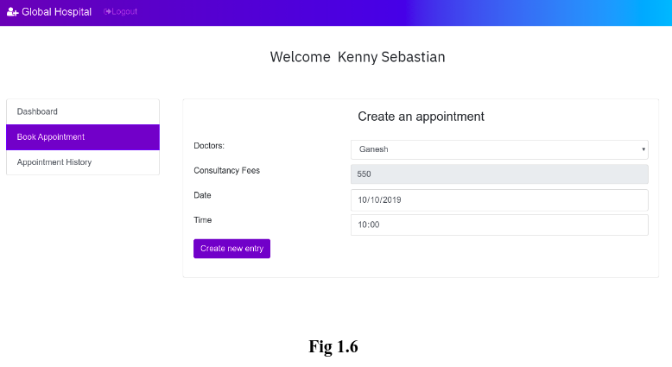

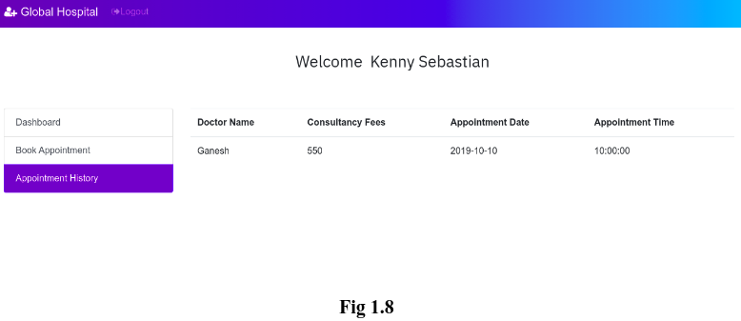

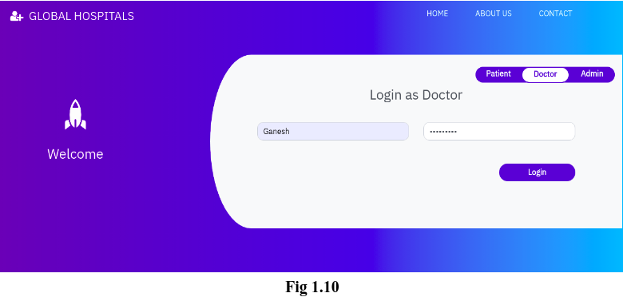

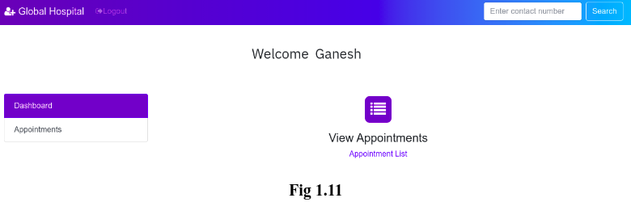

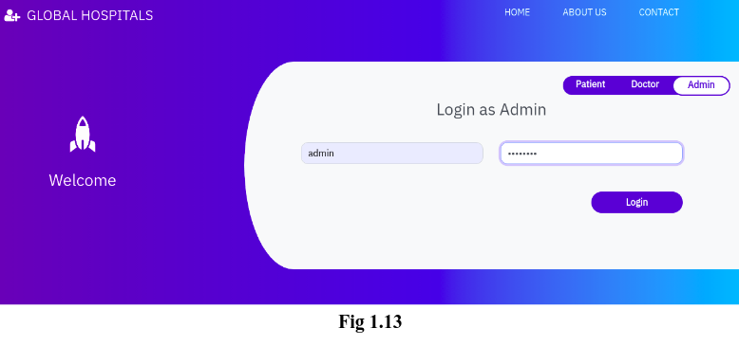

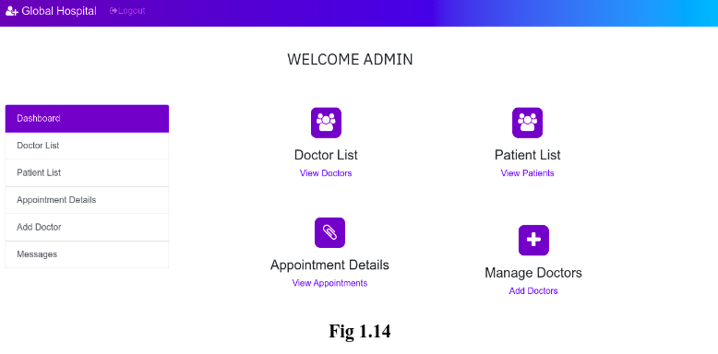

**CHAPTER 6**

**CONCLUSION**

In conclusion, the development and implementation of a full-stack hospital management website mark a significant advancement in enhancing the efficiency, accessibility, and overall quality of healthcare services. The integration of both front-end and back-end technologies allows for a seamless and user-friendly experience for both healthcare professionals and patients.

Through the utilization of modern web technologies, such as responsive design and intuitive user interfaces, the hospital management website ensures accessibility across various devices, making information readily available to users at any time and from anywhere. This accessibility fosters improved communication, coordination, and collaboration among healthcare providers, leading to enhanced patient care.

The robust back-end infrastructure plays a crucial role in managing and processing vast amounts of data generated in a healthcare setting. This includes patient records, appointment scheduling, inventory management, and other critical functionalities. The full-stack approach facilitates the integration of diverse systems, streamlining operations and reducing the likelihood of errors.

Security is a paramount concern in healthcare, and the full-stack development of the hospital management website ensures the implementation of robust security measures. This safeguards sensitive patient information, maintains the integrity of data, and complies with regulatory standards, instilling trust among both healthcare professionals and patients.

Moreover, the continuous evolution of healthcare technologies demands a scalable and adaptable solution. The full-stack architecture allows for flexibility in incorporating new features, updates, and integrations to keep pace with the dynamic nature of the healthcare industry. This adaptability ensures that the hospital management website remains relevant and effective in addressing the evolving needs of the healthcare ecosystem.

In conclusion, the development of a hospital management website using a full-stack approach not only streamlines daily operations but also contributes to the overall improvement of healthcare delivery. By combining cutting-edge technologies, user-centric design, and a robust back-end infrastructure, such a website becomes an invaluable tool in promoting efficiency, accuracy, and accessibility in the healthcare domain.

**REFERENCE**

* "Full Stack Development with JHipster" by Deepu K Sasidharan and Sendil Kumar
* "MEAN Web Development" by Amos Q. Haviv
* W3Schools (https://www.w3schools.com): A resource for learning web technologies with tutorials and references.
* Stack Overflow (https://stackoverflow.com): A community-driven platform where developers discuss and share their knowledge. You can find discussions on full-stack development and specific technologies.
* "Hospital Management System - A Case Study" by Pradeep Reddy Mamidi (International Journal of Computer Science and Information Technologies)